Adoption of Cloud in Non Financial Sectors
Cloud computing’s blend of scalability, agility and pay-per-use costs—combined with mobile, social and analytics technologies—can play a role in helping companies adapt to the new environment. It is also paving the way for smoother digital transformation by making companies more flexible, Nimble and provide better security. Some of the key players who are offering the cloud as Infrastructure as Service ( IaaS ) are Amazon,Google,Microsoft and IBM. These companies are called Public Cloud Providers. Then there are Private cloud Providers like VMware, Rackspace etc. The table below by the world’s leading research and advisory company Gartner clearly shows the potential of Cloud computing and its adoption
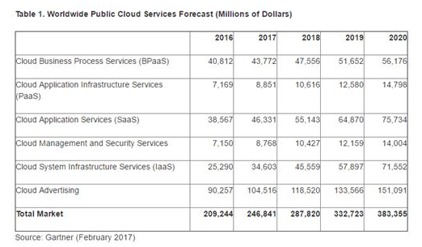
Top 5 sectors other than Banks which have rapidly adopted cloud are
- Automotive
- Media and Entertainment
- Retail
- Healthcare
- Insurance

- Automotive
- The cloud enabled global product development to testing the prototypes.
- Integrating the global suppliers network helps company save millions by placing orders Just In Time
- Cloud computing also enables the enhanced analytics and reporting for plant operations.
- At retail level Cloud not only enables better inventory management by dealers but also helps in providing better customer feedback on the products via social media analytics and real-time monitoring of consumer behavior.

- Media and Entertainment:
The Pay per use and easy scalability of the cloud resources has revolutionized the media and entertainment industry. Companies Netflix,Hulu and Hotstar which have event based or time based surge in users have successfully adopted the cloud to optimize their infrastructure cost. The benefits are passed onto customers via lower costs which in turn helped these companies to rapidly scale-up their user base and revenues.
- Retail :
- Cloud enables better inventory management by providing better supply chain visibility.
- Cloud helps in avoiding stock-outs, expedited deliveries, or high inventories
- Cloud also helps to capture real-time status of consignments, digitized documents from suppliers, carriers, logistics providers, brokers etc.
- Cloud enables hosting powerful analytics tools which provide customer insights and product preference by analyzing customer behaviors via social media like Twitter, Instagram, Facebook etc. or via consumption pattern.
- Healthcare:
Clinical information Management has been the Achilles Heel of the health care industry. Health care is one of the most highly regulated industry where complex licenses and protocols are required to perform even the simplest of the task. Cloud has a huge potential here and it has already proved its importance. Cloud providers have easily adapted to the stringent HIPAA protocols there by paving way for revolutionizing the industry. With the advent of the IoT and smart devices which produces millions of real-time data across geographical locations only cloud has the capability of handling the massive data.
- Insurance :
Another industry that is as heavily regulated as the Healthcare is the insurance industry. At a high level Insurance industry like banking can be classified into 2 segments Core Business and Support. Like any other business segment companies are more willing to experiment by adapting new technology in the least risk averse sections of their business. The adoption of Cloud in various support services has helped in running complex risk, interest rates and reserve requirement calculations for regulatory reporting. Ex: IFRS 17. By aggregating various data like weather, political uncertainty companies can build risk model and adapt business accordingly.

